Nepal College of Information Technology

**Unit Test**

Spring 2012

Program : BE IT Time : 2 hrs

Semester : (VI) FM : 70

Subject : Electronic Device PM : 35

* *Candidates are requested to give their answer as far as practicable in their own words.*
* *The figure in the margin indicates the full marks*
* ***Attempt ALL question***

1. a) Differentiate linear and non-linear devices. “Diode is a non-linear device,” justify it. (4+4)

b) Find current through the diode (assume piecewise linear model). (7)

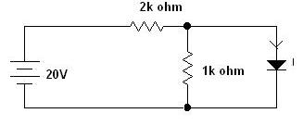

2. a) Explain the reverse recovery time of PN junction diode with the help of neat and clean timing diagram. (8)

b) Find the piecewise linear model of diode in diode with Is = 10-11 A and η = 1.6 in the vicinity of operating point ID = 1mA. (7)

3. a) Briefly explain the tunneling phenomenon of tunnel diode. Draw its VI characteristics. (6+2)

b) Determine the range of values of Vin that will maintain the zener diode in the “ON” state. Also find the maximum power that can be dissipated to the diode. (7)

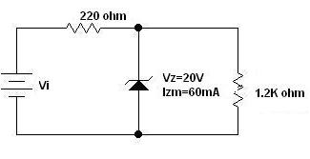

4. a) Explain the operation of half wave rectifier and find its efficiency. (5)

b) Draw the output waveform (assume ideal diode). (5)

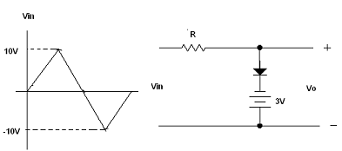

c) Draw the output waveform (assume ideal diode). (5)

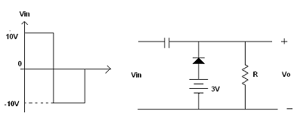

5. Write short notes (any two) (2*5)

a) Diffusion and Transition Capacitance

b) Intrinsic and extrinsic semiconductor

c) Zener and avalanche breakdown

d) Piecewise linear modeling